**Software Requirements Specification**

**For**

**Flight Booking System, Version 1.0**

Table of Contents

Table of Contents ii

1. Introduction 1

1.1 Purpose 1

1.2 Project Scope 1

2. Overall Description 1

2.1 Product Function 1

3. Use Case Diagram 2

4. Database Design 3

5. Class Diagarm 4

6. Activity Diagram 6

7. UI Designs 7

# Introduction

## Purpose

Flight booking System refers to systems that enable customers to book tickets for flights through a personal computer or other intelligent device. The main intention behind the commencement of electronic ticket booking services is to provide the customers with an alternative that is more responsive and with less expensive options. With options just a click away, customers have more control than ever. Their expectations are usability and real-time answers. They also want personal attention and highly customized products and services.

## Project Scope

The scope of this project is limited to the activities of the operations unit of the flight booking system which includes customers registering a new account, signing into existing account, search and book flight tickets, cancel tickets, viewing the history of booked tickets etc.,

# Overall Description

## Product Functions:

* Customer can make a search operation to find flights between origin and destination cities.
* Customer can make a book their desired flight.
* Customer can view his/her history of all booked tickets and edit his own profile.
* Admin adds new flight details to existing database.
* Admin adds edit/delete existing flight details in database.
* Admin can view all the flights booked by registered accounts.

# Use Case Diagram

The use-case diagram of the Flight booking system shows all different actors involved in the system and their respective use cases.

A close up of a map

Description generated with high confidence

# Database Design

**A screenshot of a cell phone

Description generated with very high confidence**

# Class Diagrams

The below class diagram shows that the customer can have more than one flight reservation and that relationship goes to one-many relationship.

**A screenshot of a cell phone

Description generated with very high confidence**

# Activity Diagrams

**Activity Diagram for user signin**

**A close up of text on a white background

Description generated with high confidence**

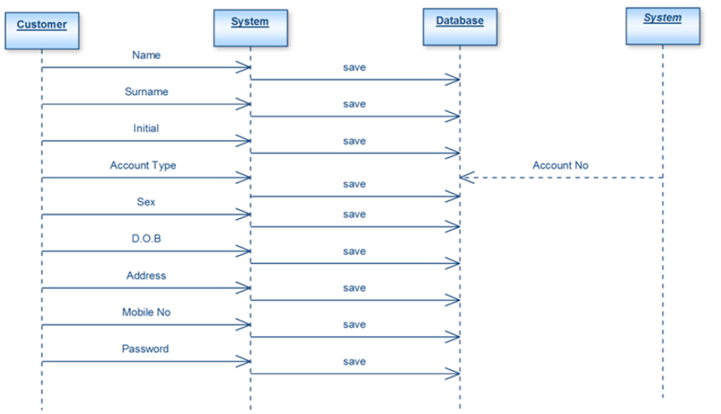

# UI Design

**Customer Registration Screen**

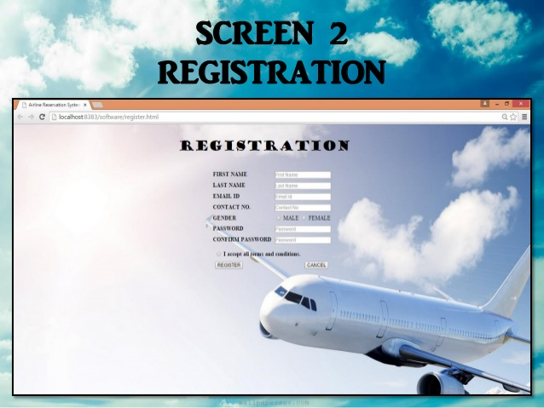

***Description:*** *This webpage is used for new customer registration.*

**User Signin**

**A screenshot of a cell phone

Description generated with very high confidence*Description:*** This page enables user to sign in.

**Flight Search:**

**A screenshot of a cell phone

Description generated with very high confidence**

***Description:*** The customer can search for flights by entering origin and destination cities and by selecting dates. The available flights for the entered information is then displayed.

**Admin Page:**

**A plane in the water

Description generated with high confidence**

**A screenshot of a cell phone

Description generated with very high confidence**

***Description:*** Admin can land into a separate homepage using admin login credentials. Admin can perform the following actions:

* Add new Airline detail
* Edit existing Airline detail
* Delete existing Airline detail
* View all booked tickets by customers